# Section 2.4: Continuity

## Continuity at a Point

A function is considered continuous if we can trace the graph with a pencil without lifting the pencil from the page. Points where you must lift the pencil are considered **points of discontinuity**.

A function $f(x)$ is **continuous at a point $a$**  if and only if the following three conditions are satisfied:

* $f\left(a\right)$ is defined (no holes)
* $\lim_{x→a}{f(x)}$ exists (no breaks)
* $\lim_{x→a}{f(x)}=f(a)$ (no jumps)

A function is **discontinuous at a point $a$**  if it fails to be continuous at $a$.

Media: Watch this [video](https://youtu.be/SoMl89ZYJIg) example on continuity of piecewise functions.

Examples: Using the definition of continuity, determine whether the given function is continuous at the given point. Justify the conclusion.

1. $f\left(x\right)=\frac{x^{2}-4}{x-2}$ at $x=2$
2. $f\left(x\right)=\left\{\begin{matrix}-x^{2}+4 & \text{if} x≤3 \\ 4x-8 & \text{if} x>3\end{matrix}\right.$ at $x=3$
3. $f\left(x\right)=\left\{\begin{matrix}\frac{\sin{x}}{x} & \text{if} x≠0 \\ 1 & \text{if} x=0\end{matrix}\right.$ at $x=0$
4. $f\left(x\right)=\left\{\begin{matrix}2x+1 & \text{if} x<1 \\ 2 & \text{if} x=1 \\ -x+4 & \text{if} x>1\end{matrix}\right.$ at $x=1$

### Continuity of Polynomials and Rational Functions

Polynomials and rational functions are continuous at every point in their domains.

Media: Watch this [video](https://youtu.be/c3Reun41OGI) example on continuity of polynomial and rational functions.

Examples

1. For what values of $x$ is $f\left(x\right)=\frac{x+1}{x-5}$ continuous?
2. For what values of $x$ is $f\left(x\right)=3x^{4}-4x^{2}$ continuous?

## Types of Discontinuities

Discontinuities can take on several different appearances. A **removable discontinuity** is a discontinuity for which there is a hole in the graph. A **jump discontinuity** is a noninfinite discontinuity for which the sections of the function do not meet up. An **infinite discontinuity** is a discontinuity located at a vertical asymptote.

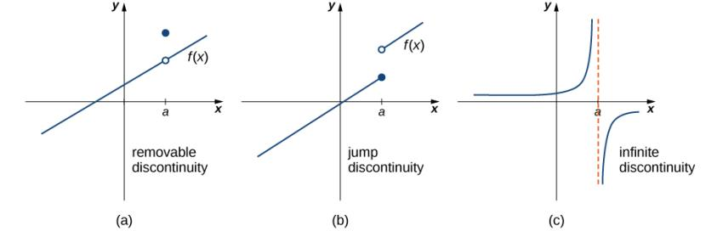

If $f(x)$ is discontinuous at $a$, then $f$ has

1. a **removable discontinuity** at $a$ if $\lim_{x→a}{f(x)}$ exists.
2. a **jump discontinuity** at $a$ if $\lim_{x→a^{-}}{f(x)}$ and $\lim_{x→a^{+}}{f(x)}$ both exist, but $\lim_{x→a^{-}}{f(x)}≠\lim_{x→a^{+}}{f(x)}$.
3. an **infinite discontinuity** at $a$ if $\lim_{x→a^{-}}{f(x)}=±∞$ or $\lim_{x→a^{+}}{f(x)}=±∞$.

Media: Watch these [video](https://youtu.be/TVBg-agZsIY)1 and [video2](https://youtu.be/M8XxZpq_-VI?t=72) examples on classifying discontinuities.

Media: Watch this [video](https://youtu.be/LJCLiCOr4ek) example on determining a limit analytically.

Examples

1. Determine whether $f\left(x\right)=\frac{x+2}{x+1}$ is continuous at $-1$. If the function is discontinuous at $-1$, classify the discontinuity as removable, jump, or infinite.
2. For $f\left(x\right)=\left\{\begin{matrix}x^{2} & \text{if} x≠1 \\ 3 & \text{if} x=1\end{matrix}\right.$, decide whether $f$ is continuous at $1$. If the function is discontinuous at $1$, classify the discontinuity as removable, jump, or infinite.
3. Consider the graph of the function $y=f(x)$ shown in the following graph.

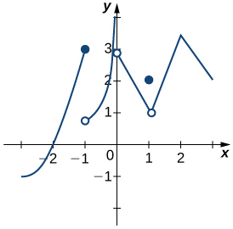

1. Find all values for which the function is discontinuous.
2. For each value in part a, state why the formal definition of continuity does not apply.
3. Classify each discontinuity as either jump, removable, or infinite.
4. Suppose $y=f(x)$. Sketch a graph with the indicated properties:
   * Discontinuous at $x=1$

$\lim_{x→-1}{f(x)}=-1$

$\lim_{x→2}{f(x)}=4$

## Continuity over an Interval

A function is continuous over an interval if we can use a pencil to trace the function between any two points in the interval without lifting the pencil from the paper. Before looking at what it means to be continuous over an interval, we need to understand what it means for a function to be continuous from the right at a point and continuous from the left at a point.

**Continuity from the Right and from the Left**

A function $f(x)$ is said to be **continuous from the right** at $a$ if

$\lim_{x→a^{+}}{f(x)}=f(a)$.

A function $f(x)$ is said to be **continuous from the left** at $a$ if

$\lim_{x→a^{-}}{f(x)}=f(a)$.

**Continuity over an Interval**

A function is continuous over an open interval if it is continuous at every point in the interval.

A function $f(x)$ is continuous over a closed interval of the form $[a,b]$ if it is continuous at every point in $(a,b)$ and is continuous from the right at $a$ and is continuous from the left at $b$.

A function $f(x)$ is continuous over an interval of the form $(a,b]$ if it is continuous over $(a,b)$ and is continuous from the left at $b$.

Continuity over other types of intervals are defined in a similar fashion.

Media: Watch this [video](https://youtu.be/mNq9t-Qr10A) example on finding intervals of continuity.

Media: Watch this [video](https://youtu.be/GF4OBVXGqSM) example on sketching graphs with given conditions.

Examples: State the interval(s) over which the given function is continuous.

$f\left(x\right)=\frac{x-1}{x^{2}+2x}$

$f\left(x\right)=\sqrt{4-x^{2}}$

1. Sketch the graph of the function $y=f(x)$ with the following properties:
   * The domain of $f$ is $(-∞,∞)$.
   * $f$ has an infinite discontinuity at $x=-6$.
 $f\left(-6\right)=3$ $\lim_{x→-3^{-}}{f(x)}=\lim_{x→-3^{+}}{f(x)}=2$ $f\left(-3\right)=3$ $f$* is left continuous but not right continuous at $x=3$
   * $\lim_{x→-∞}{f(x)}=-∞$ and $\lim_{x→+∞}{f(x)}=+∞$

## The Intermediate Value Theorem

Functions that are continuous over intervals for the form $[a, b]$, where $a$ and $b$ are real numbers, exhibit many useful properties. The Intermediate Value Theorem helps us determine whether solutions exist before going through the process to find them.

**The Intermediate Value Theorem**

Let $f$ be continuous over a closed, bounded interval $\left[a, b\right]$. If $z$ is any real number between $f\left(a\right)$ and $f\left(b\right)$, then there is a number $c$ in $\left[a, b\right]$ satisfyling $f\left(c\right)=z.$

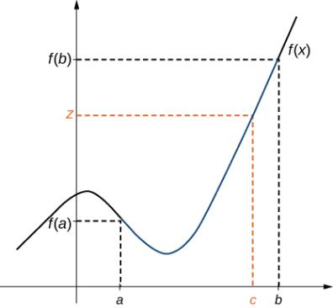

Media: Watch this [video](https://youtu.be/5hK6RWeg0yU) example on the Intermediate Value Theorem.

Examples

1. Show that $f\left(x\right)=x^{3}-x^{2}-3x+1$ has a zero over the interval $[0,1]$.
2. Show that $f\left(x\right)=x-\cos{x}$ has at least one zero.